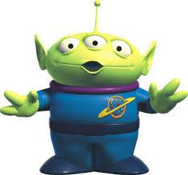
Southbound on the Freeway
A tourist came in from Orbitville,  parked in the air, and said:  The creatures of this star  are made of metal and glass.  Through the transparent parts  you can see their guts.  Their feet are round and roll  on diagrams--or long  measuring tapes--dark  with white lines.  They have four eyes.  The two in the back are red.  Sometimes you can see a 5-eyed  one, with a red eye turning  on the top of his head.  He must be special-  the others respect him,  and go slow,  when he passes, winding  among them from behind.  They all hiss as they glide,  like inches, down the marked  tapes. Those soft shapes,  shadowy inside  the hard bodies--are they  their guts or their brains? | Where does the “tourist” in the poem live?  Why does the speaker use the term “tourist”? What does it suggest about this person?  What is the tourist describing?  Paraphrase stanza 7.  List all the alliteration.  What sense does the imagery in line 21 appeal to?  List the onomatopoeia.  Why does the poem end with a question?

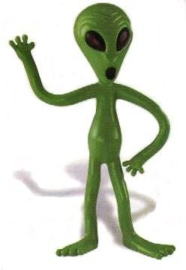
Writing Exercise
You will find a bag in front of you. In it, you will find several unique items. It is your job to create a poem inspired by one of these objects. There is a catch, though! In order to create your poem, you must write as if you are an alien seeing this item for the first time! Describe this item using imagery, figurative language, and of course, creativity!

Poem must include:
- 10 lines or more
- Alliteration
- Onomatopoeia
- Internal Rhyme, External/End Rhyme OR Repetition (at least one!)
- Imagery (Description using the senses)

