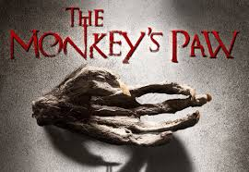
“The Monkey’s Paw”
Vocabulary Hunt for new words: Search your classmates vocab words for words you don’t know
Vocabulary word | Definition | ______ is like ______ | Picture
Example:  Scarce | barely; not a lot of something | Scarce is like the shelves at Target after Black Friday. | 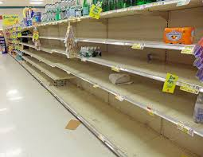
“Fate rules people’s lives and those that interfere with it do so to their own sorrow.”

“The Monkey’s Paw”
Character | Action | Inference
Example: Mr. White | “The old man rose with hospitable haste… was heard condoling with the new arrival” | Mr. White is a good host and is interested in his friend’s arrival.
Mr. White

Mrs. White

Herbert White

Major Morris

Text Questions:
Question | Answer
- What does Mr. White mean by, “I should hardly think that he’d come tonight”?

- Why does Major Morris say, “better let it burn”?
- What does Major Morris mean when he says, “It had a spell put on it by an old fakir… a very holy man. He wanted to show that fate ruled people’s lives, and that those who interfered with it did so to their own sorrow.”?
- Identify an example of foreshadowing from the text. (cite evidence- quote)
- What is the first wish and what could a possible consequence be?
- Read the last 2 paragraphs from section 1, how does Mr. White’s attitude toward the paw shift after his experience with the fire? (cite evidence- quote)
- How do the words “sinister” and “awful” contribute to the tone of the text?
- How does the mood shift in section 2? Describe what is happening.
- What would you wish for next if you are the Whites?
- What is the main conflict in section 3? Internal or external?
- What is Mr. White’s 3rd and final wish? (cite evidence- quote)
- Write the first line of the story
- Write the last sentence of the story
- What is the author’s purpose of beginning and ending the story describing the setting?
- How does the setting at the end contrast to the setting at the beginning?

