Strategy | Quote from Text

“The Most Dangerous Game”
Suspense, Conflict, and Plot
Step 1: As you read “The Most Dangerous Game” by Richard Connell, identify the strategies he used to create suspense. **Strategies can include word choice, imagery, foreshadowing, flashback, omission of events, text structure, etc.
Step 2: As you read, identify examples of conflict from the story. (use quotes)
Character vs. Character
Character vs. Nature
Character vs. Society

EXPOSITION: What happens at the beginning of the story?

Setting:

Characters:
CLIMAX: What is the suspenseful, turning point in the story?
STORY
Title: The Most Dangerous Game
Author : Richard Connell
FALLING ACTIONS:What events happen after the climax?

1.

2.

3.
EXPLAIN THE CONFLICT:
RESOLUTION: How does the story end?
PROTAGONIST vs. ANTAGONIST

_____________ vs. _____________
RISING ACTIONS: What events lead to the climax?

4.

3.

2.

1.
CONFLICT

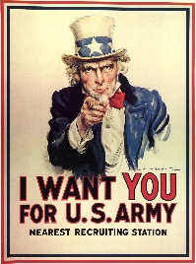
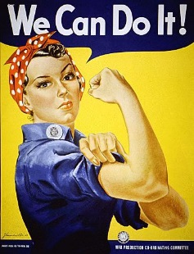
The competition is heated and you must help! Rainsford is determined to convince people to stay far away from the island while Zaroff is desperate to recruit players for his “game.” What will you do to help? It is your job to create an advertisement to sway people one way or the other!
“The Most Dangerous Game”

Propaganda is information, ideas, or rumors deliberately spread widely to help or harm a person, group, or institution. You will need to use the same ideas propaganda posters use in order to persuade people to avoid or visit the island!
Bias
A strong opinion about something; it may be in favor of something or against it

Step 1: Which way will YOUR bias fall? Circle the character you will side with for your advertisement?
Rainsford vs. Zaroff

Step 2: Create a slogan!
Decide what loaded words you will have on your advertisement.
Example: What would make you want to drink a Pepsi more?
Loaded Words
Words that attempt to influence the certain audience by using an appeal to emotions

List any loaded words you see in the text.

"Drink our super unhealthy beverage that may destroy your bones and teeth" or "Open Happiness."
Come up with a slogan using loaded words for your advertisement now!
_____________________________________________________
_____________________________________________________

Step 3: Choose ONE of the following to add to your advertisement!
Precise Languageusing specific words to convey an exact idea) OR
Euphemisma harmless or polite word or phrase used to replace a more offensive one)
Write your precise language OR Euphemism here: _____________________________________________________
_____________________________________________________

Step 4: Include examples of connotation and denotation
Connotation the associated or secondary meaning of a word or expression in addition to its direct meaning; usually has an emotional association and can be positive or negative (Example. Hunt=Game)
List the connotation you will use on your advertisement here: ________________________________________________________________________________________________________
CHECKLIST: Check off each one of these when you have added it to your poster.
- Bias
- Loaded Words
- Euphemism OR Precise Language
- Connotation
- Denotation
- Visual Aid

Denotation the explicit or direct meaning of a word – the dictionary definition: (Example: Hunt= pursue and kill (a wild animal) for sport or food)
List the denotation you will use on your advertisement here:
________________________________________________________________________________________________________
Step 5: Include a visual aid! Help convince people by drawing in their attention! Find the perfect picture for your advertisement!

