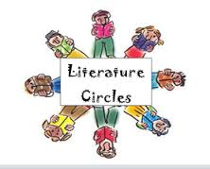
Name____________________ Lit Circle Book_________________ Pages 1-______

Literature Circle Focus and Summary- Week 1
Focus: Characters and Conflict
Part 1: Summary- Write a brief summary of this week’s reading. Include any important information about characters, setting, conflict, and major events. Your summary should be at least 5 sentences.
________________________________________________________________________________________________________________________________________________________________________________________________________________________________________________________________________________________________________________________________________________________________________________________________________________________________________________________________________________________________________________________________________________________________________________________________________________________________________________________________________________________________________________________________________________________________________________________________________________________________________________________________________________________________________________________________________________________________________________________________________________________
Part 2: Focus- Characters and Conflict- Fill in the answers below using Part of the Question (complete sentences)
- Who are the main characters? Which characters are protagonists or antagonists?

- Which characters are flat and which are round?

- How does the main character compare or contrast to Ponyboy?

- What are the conflicts occurring at this point in the novel? Name and describe at least one internal and one external conflict. .

- Compare and contrast one conflict in this novel to a conflict in The Outsiders.

