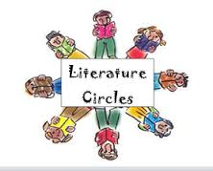
Name_____________________Lit Circle Book___________________Pages ___-______________

Literature Circle Focus and Summary- Week 2
Focus: Inference, Predict, Vocabulary
Part 1: Summary- Write a brief summary of this week’s reading. Include any important information about characters, setting, conflict, and major events. Your summary should be at least 5 sentences.
__________________________________________________________________________________________________________________________________________________________________________________________________________________________________________________________________________________________________________________________________________________________________________________________________________________________________________________________________________________________________________________________________________________________________________________________________________________________________________________________________________________________________________________________________________________________________________________________________________________________________________________________________________________________________________________________________________________________________________________________________________________________________________________________________________________________________________
Part 2: Focus- Inference, Predict, Vocabulary- Fill in the answers below using Part of the Question (complete sentences)
- Make 5 inferences based on events that have happened in the novel so far. Describe the event and the inference.

- Predict the resolution of the story based on some inferences that you have made.

- What are 2 important settings in the novel? How do these settings impact the plot?

- Write down 5 words from the novel that are difficult or you don’t understand the meaning. Use context clues or a dictionary to find the meaning and write it down beside the word.

