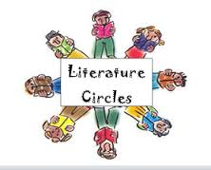
Name______________________________________
Lit Circle Book_______________________________ Pages __________________________

Literature Circle Focus and Summary- Week 3
Focus: Plot, Theme
Part 1: Summary- Write a brief summary of this week’s reading. Include any important information about characters, setting, conflict, and major events. Your summary should be at least 5 sentences.
__________________________________________________________________________________________________________________________________________________________________________________________________________________________________________________________________________________________________________________________________________________________________________________________________________________________________________________________________________________________________________________________________________________________________________________________________________________________________________________________________________________________________________________________________________________________________________________________________________________________________________________________________________________________________________________________________________________________________________________________________________________________________________________________________________________________________________
Part 2: Focus- Plot and Theme- Fill in the answers below using Part of the Question (complete sentences)
- What is the overall theme of the novel? Why? Find text evidence to support your answer.

- Draw a plot cliff (diagram) on the back of this sheet of paper. Fill in all parts of the plot cliff for your novel.

- What was the main conflict of the novel? Is the main conflict resolved in the resolution? Why or why not?

- Which characters are dynamic? Find proof of this change using text evidence.

